Conference Name: Future Payment Summit 2019
Date: 14th June 2019
Location: Mumbai
Tagline: Delivering Innovation in Payment
TABS:
- HOME
- ADVISORY BOARD MEMBERS & SPEAKERS
- DONWLOAD BROCHURE (FORM)
- EVENT PARTNERS
  - EVENT PARTNERS
  - MEDIA PARTNERS
  - PROMOTE YOUR BUSINESS
- REGISTER NOW (FORM)
- CONTACT US (FORM)

Website only for reference - http://www.ngdxindia.com/
WEBSITE HOMEPAGE
About Future Payment Summit 2019
The launch edition of Future Payment Summit is an exclusive industry platform designed for organizations that are driving innovation, transforming through new solutions and adopting emerging trends and technologies to meet their business needs and transact with their customers.
The agenda will feature exclusive sessions and panel discussions from Industry’s best brains on how they are defining their current and future strategies for viable growth. Payment professionals and technology solution providers will unite to debate and explore the pain points and opportunities. Attend the Future Payment Summit and get the latest on all exciting technologies and business opportunities.
Advsiory Board Members & Speakers (slider)
Picture name, designation with company name
Coming soon…
Who will you meet?
DESIGNATIONS
➢Sr. Management – Director, VP, GM, CXO, etc
➢Mid Management – Sr. Manager, Manager, etc
➢Others – Consultants, Advisors, etc
PROFILE
➢Payment
➢E-Business
➢Technology
➢Innovation
➢Digital Transformation
➢Operation
➢R&D
INDUSTRY
➢ BFSI
➢ Retail
➢ E-Commerce
➢ Telecom
➢Digital Wallets

Programme Focus/ Key Topics
➢ Payment landscape and its future in India
➢ Mobile wallet adoption and its impact on industries
➢ Cashless Economy – Where do we stand?
➢ P2P Block chain marketplace
➢ Global payment challenges

Venue (map)
Footer Details: (Contacts)
To register as a delegate, contact: | Ram Shukla |  | 226172 7227 | 99307 92737 | ram.shukla@ubm.com
For exhibit and speaking opportunities, contact: | Dhruv Khanna |  | 226172 7305 | 9930307433 | dhruv.khanna@ubm.com
For marketing communications, contact: | Sean Palanna |  | 226172 7072 | 99208 57525 | sean.palanna@ubm.com

TAB: ADVISORY BOARD MEMBERS & SPEAKERS
Picture name, designation with company name
coming soon….

TAB: DONWLOAD BROCHURE
Form reference: http://www.ngdxindia.com/DownloadBrochure.aspx
TAB: EVENT PARTNERS
- EVENT PARTNERS (TBA)
- MEDIA PARTNERS (TBA)
- PROMOTE YOUR BUSINESS
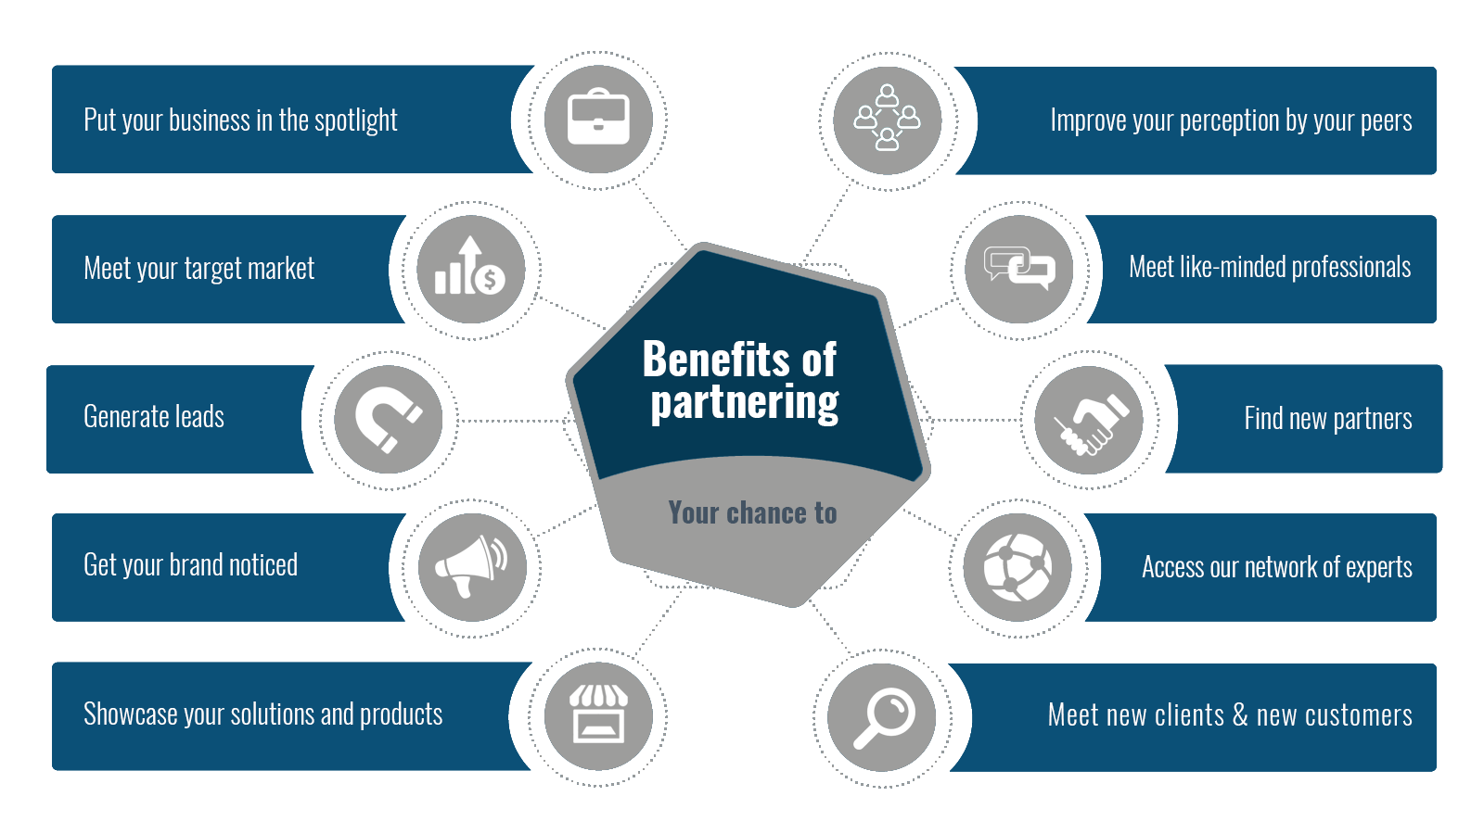
TAB: REGISTER NOW
TAB: CONTACT US (FORM)

